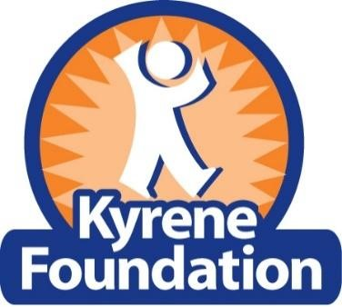
2023 Teacher Mini Grant Application
The Kyrene Foundation awards mini grants to provide enhanced learning opportunities for students.
Kyrene teachers may apply for up to $500.00 per classroom for items such as guest speakers, supplies, materials, equipment, and educational study trips. The grant application consists of 1) signed application cover page and 2) and a 2-page maximum narrative. 3) teachers may combine classes (ie. 3 classes can go together and apply for up to $500 classroom or $1500)
Completed grant applications must be received no later than 4:00 pm on Monday, January 23, 2023.
All applicants will be notified of their status on or before Wednesday, February 1, 2023.
The narrative must contain six (6) sections:
- Purpose of the request
- Potential impact on student learning and number of students included
- Evaluation plan for the learning opportunity for students
- Correlation of the learning opportunity for students to the KSD curriculum
- Project completion date and approximate timeline of the learning opportunity for students
- Itemized budget
Teachers who are awarded the mini grant are required to submit a brief evaluation report along with a photo (or short video) of the learning opportunity for students within two weeks of the completion date.
Reimbursement will not be made until this requirement is met. Requests for reimbursement must be submitted no later than May 1, 2023.
Please Note:
- Late, incomplete or unsigned applications will not be considered.
- Only ONE application per teacher per year is allowed.
- All receipts for reimbursement must be submitted AT ONE TIME no later than May 1, 2023 . Only receipts (up to) the awarded amount will be reimbursed.
- All activities related to the project need to occur prior to May 1, 2023 .
Completed applications should be e-mailed by 4 p.m. Monday, January 23, 2023: debra.hoover@kyrenefoundation.org
Part 1: Cover Page
Teacher Name(s): School:
Title of Grant Request:
Kyrene Email Address for submitting teacher:
Grade(s) and/or Subject(s):
Total Amount of Request: | Number of Students Impacted:
I understand & agree to follow all grant guidelines. Teacher’s Signature & Date: ___________________________

Principal’s Review Section:

Yes No
This grant request supports the school improvement plan.
This grant request supports the KSD Curriculum.
I support this grant request.
- Completed applications should be e-mailed by 4 p.m. January 23, 2023 to: debra.hoover@kyrene.foundation
- Principal’s Signature & Date (Required) ___________________________________

Kyrene teachers may apply for up to $500.00 per classroom for items such as guest speakers, supplies, materials, equipment, and educational study trips (Note: workshops are not eligible for funding).
NARRATIVE PART 2
( Narrative below to be completed by teacher or teacher team ) School Name:
Teacher(s) Name(s):
Amount Requested:
The narrative must contain full responses to all six (6) sections ( not to exceed 2 pages ):
Section 1: Purpose of Request Type here:
Section 2: Potential Impact and Number of Students impacted Type here:
Section3: Evaluation Plan (with specific Pre/Post project data) Type here:
Section 4: Alignment to KSD Curriculum (be specific) Type here:
Section 5: Specific Timeline of Activities and Completion Date Type here:
Section 6: Itemized Budget Type here:
2 Completed applications should be e-mailed by 4 p.m. February 1 to: debra.hoover@kyrenefoundation.org

